1. Which are the top three variables in your model which contribute most towards the probability of a lead getting converted?

Ans. As per our calculations the three variables that contribute most towards the probability of a lead getting converted are 1)Total Time Spent on Website, 2)Lead Add Form and 3)Had a Phone Conversation

1. What are the top 3 categorical/dummy variables in the model which should be focused the most on in order to increase the probability of lead conversion?

Ans. According to the coefficients the top three dummy variables with the probability of lead conversion are 1) Phone Conversation Lead Add Form,2) Lead Add Form and 3)Working Professional

1. X Education has a period of 2 months every year during which they hire some interns. The sales team, in particular, has around 10 interns allotted to them. So during this phase, they wish to make the lead conversion more aggressive. So they want almost all of the potential leads (i.e. the customers who have been predicted as 1 by the model) to be converted and hence, want to make phone calls to as much of such people as possible. Suggest a good strategy they should employ at this stage.

Ans. As per our calcluation the cutoof is 0.4 fr the final prediction

To convert leads to coustmers the interns have to concentrate on 1’s as shown below

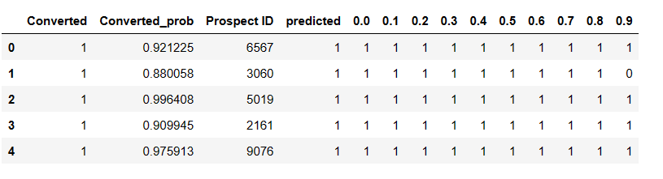

1. Similarly, at times, the company reaches its target for a quarter before the deadline. During this time, the company wants the sales team to focus on some new work as well. So during this time, the company’s aim is to not make phone calls unless it’s extremely necessary, i.e. they want to minimize the rate of useless phone calls. Suggest a strategy they should employ at this stage.

Ans. As per our calculation we must targrt the customers with value 1 to minimise the uncessary call, We have o also make sure we do not miss our on leads wchich were already contacted